1. For handling huge number of request, we are using load-balancing using zuul proxy.
2. For that we need to register our application instances in eureka server. Eureka server is used to enlist all services so that each service can discover other service from the list.
3. We start our eureka server : <http://localhost:9090/>

Below is the screenshot for the same:

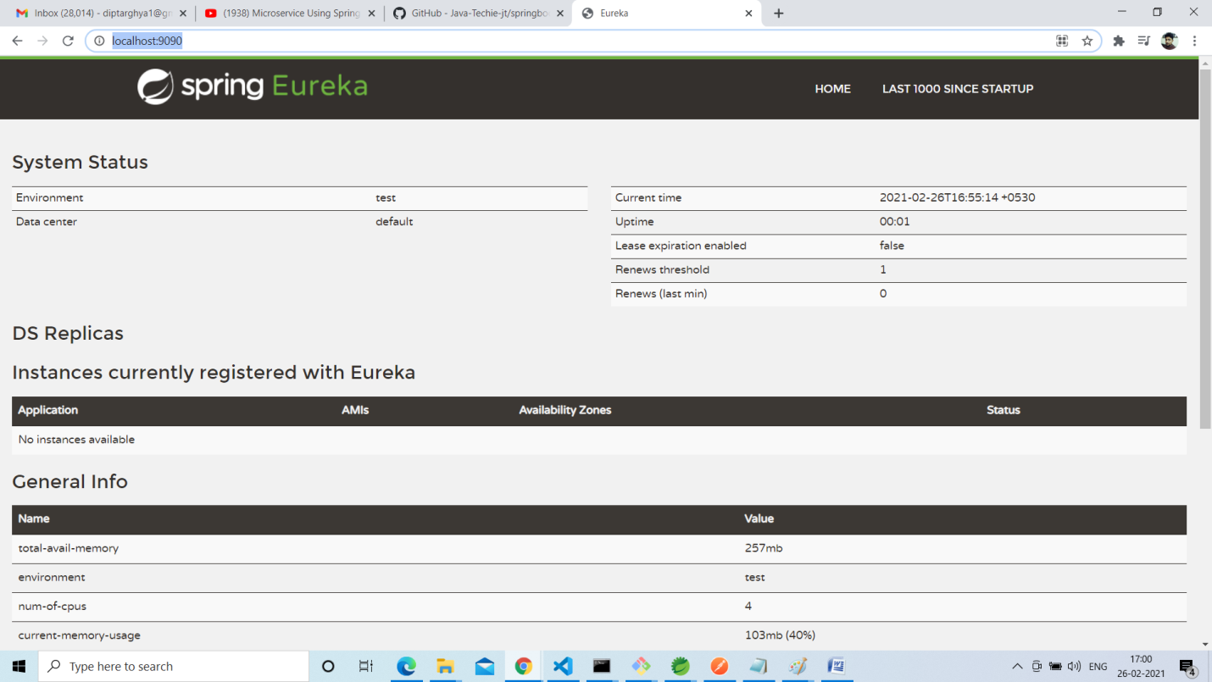

1. We register our Weather services. We are creating two application instances .
2. We register our zuul load balancer proxy . This will act as API gateway. So the request will come to load balancer and it will redirect to the application instance based on the availability.

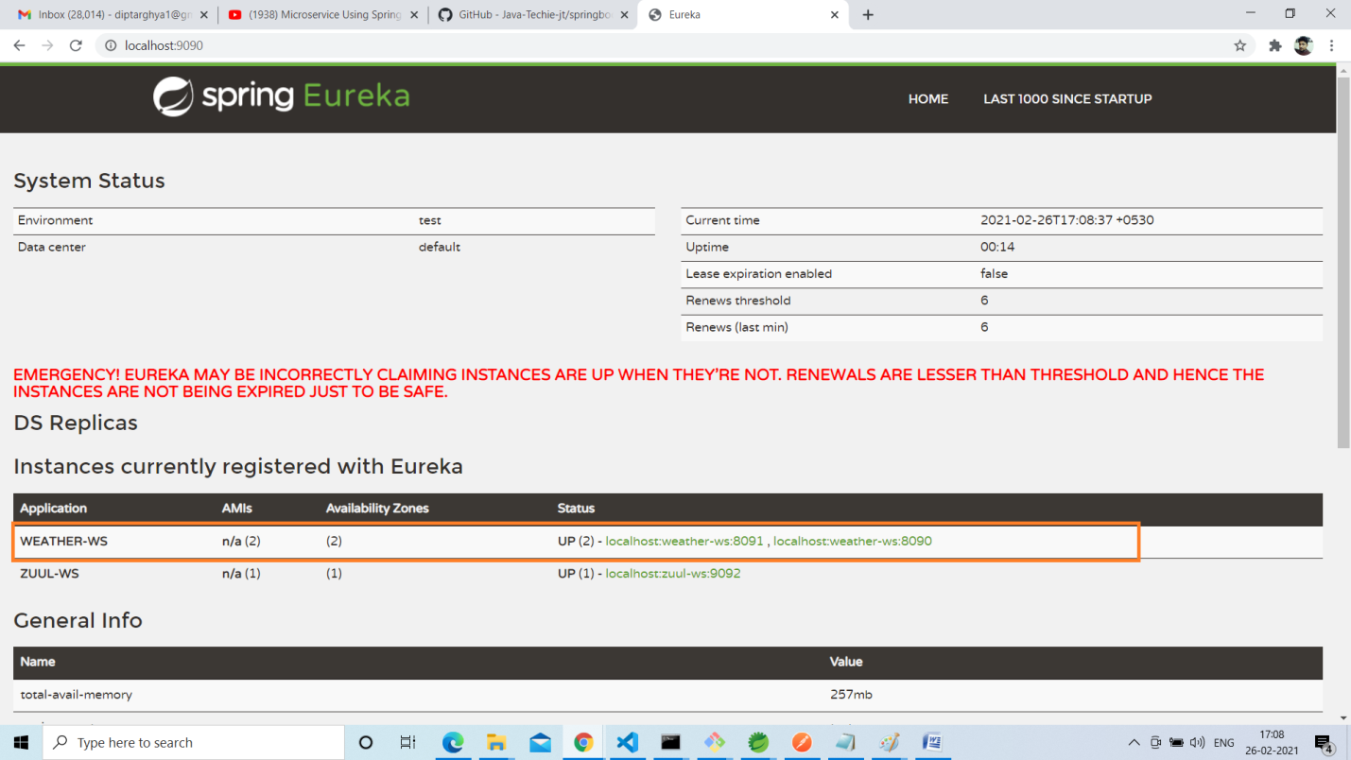

1. Now we call our weather service using the API gateway (zuul).

